This is the Raven’s Cry, a publication of the Barony of Raven’s Cove of the Society for Creative Anachronism, Inc. Raven’s Cry is available from Dennis Fillpot, 105 Walnut Creek Road, Jacksonville, NC 28546
This newsletter is not a corporate publication of the Society for Creative Anachronism, Inc., and does not delineate SCA policies.
© Copyright 2011, Society for Creative Anachronism, Inc.
The information on reprinting letters and artwork from this publication, contact the Chronicler, who will assist you in contacting the original creator of the piece.
Please respect the legal rights of our contributors.

Raven’s Cry
Newsletter for the Barony of Raven’s Cove March 2011 Volume 14 Issue 3

Officers of the Barony of Raven’s Cove

Baron of Raven’s Cove Baroness of Raven’s Cove
Baron Torquil Mac Taggort the Steadfast Baroness Katharine de la Vache
(Dusty Mullins) (Laura Garcia)
614 Decatur Road 165 Raintree Circle
Jacksonville, NC 28540 Jacksonville, NC 28540
910-346-3937 910-938-5789

Seneschal Exchequer
Baroness Maderun Landimor Nadya Fee
(Diana Fillpot) (Penny Bradshaw)
105 Walnut Creek Road 615 Reindeer Circle
Jacksonville, NC 28546 Midway Park, NC 28544
910-353-4920 910-650-1413

Knight Marshall Minister of Arts & Science
Baron Torquil Mac Taggort Mistress Mordeyrn Tremayne
the Steadfast (Angela Sharpe)
(Dusty Mullins) 117 Pleasant Court
614 Decatur Road Jacksonville, NC 28540
Jacksonville, NC 28540 910-548-3510
910-346-5937

Chatelaine Web Minister
Senora Dorothea Ponce Lord Johannes Wagner
(Dorothea Lopez) (Jonathan Wagoner)
220 Roosevelt Road 249 Bayberry Court
Jacksonville, NC 28540 Jacksonville, NC 28540
910-389-5460 910-346-3772

Chancellor of Minors Chronicler
THL Glee of the Abbey Baron Calledon of Halbourne
(Debra Mullins) (Dennis Fillpot)
614 Decatur Road 105 Walnut Creek Road
Jacksonville, NC 28540 Jacksonville, NC 28546
910-346-5937 910-353-4920

Chirurgeon Minister of the Lists
Angus Arran Merecwen Albern
(Leo Roy) (Gloria Long)
112 Longwood Drive 422 Walton Road Ext.
Stella, NC 28582 Midway Park, NC 8544
910-265-1664 252-723-3586

Herald
Lord Rhodi Rulfson
(Robert Garcia)
327-6 Richlands Ave
Jacksonville, NC 85246
910-581-1872

March 2011

SUN | MON | TUE | WED | THU | FRI | SAT
 |  | 1 6 pm  A&S @Gamers  Gathering | 2 | 3 | 4 | 5  Demo  9:00-4:00
6 1:00 Fighter Practice Northeast Creek Park | 7  6 pm  A&S @Torquil’s | 8 6 pm  A&S @Gamers  Gathering | 9 | 10 | 11 | 12
13 1:00 Fighter Practice Northeast Creek Park  Daylight Savings Time Starts | 14  6 pm  A&S @Torquil’s | 15 6 pm  A&S @Gamers  Gathering | 16 | 17 | 18 | 19
20 1:00 Populace Meeting -Fighter Practice Senor Juan’s | 21  6 pm  A&S @Torquil’s | 22 6 pm  A&S @Gamers  Gathering | 23 | 24 | 25 | 26
27 1:00 Fighter Practice Northeast Creek Park | 28  6 pm  A&S @Torquil’s | 29 6 pm  A&S @Gamers  Gathering | 30 | 31

April 2011
SUN | MON | TUE | WED | THU | FRI | SAT
 |  |  |  |  | 1 | 2
31:00 Fighter Practice Northeast Creek Park | 4 | 5 6 pm  A&S @Torquil’s | 6  6pm A&S @Gamers  Gathering | 7 | 8 | 9  Regional Fighter  Practice
10 1:00 Fighter Practice Northeast Creek Park | 11 | 12 6 pm  A&S @Torquil’s | 13  6 pm A&S @Gamers  Gathering | 14 | 15 | 16  Cathanar  Demo
17 1:00 Fighter Practice Northeast Creek Park | 18 | 19 6 pm  A&S @Torquil’s | 20  6 pm A&S @Gamers  Gathering | 21 | 22 | 23
24 1:00 Fighter Practice Northeast Creek Park | 25 | 26 6 pm  A&S @Torquil’s | 27  6 pm A&S @Gamers  Gathering | 28 | 29 | 30
Doomsday Report for 2010 for the Barony of Raven’s Cove

Greetings to the populace of Raven’s Cove;

Finally warm winds begin to blow, chasing away the chills from winter, and what a winter it was. We had a hugely successful 12th Night, and the last few months have seen many member of the Cove recognized by their Majesties. The spring tourney season has begun and we have big plans in the works. We will soon begin work on stools, tables, and a baronial gathering pavilion.

On that subject I would like to address field presence. As the youngest barony in the kingdom many eyes are upon us. Also as one of the primaries in the War of the Wings we will especially be in the spotlight. We, as a group, really need to up our overall spiff level. Coolers, camp chairs, and non-period tables must somehow be disguised or covered. Anyone interested in building period style accoutrements please let me or Lord Jehan Franc know. Tuesday night armor nights at my home will now also include furniture making.

In closing, I would like to thank everyone in the group they make the Barony as a whole look good. Thanks also for your presence at events. I know how expensive travelling is right now and the effort is paying off. Please remember if there is anything that I can help you with just call me. It is my pleasure, and my duty (a duty that I take very seriously) to do whatever I can to help you.

Yours in Service,

Torquil MacTaggart
Baron

Greetings to the Populace,

The Barony has many plans and events lined up for 2011. We will be having regional fighter practices, demos, a Birthday, and maybe a Kingdom Event in the fall. To help make our “NEW” Barony shine, we will be doing A&S projects such as making chairs, tables, and items for the Baronial Pavilion. The goal of our Excellencies is not to have any mundane covered chairs if at all possible. So keep an eye out for upcoming chair classes/workshops when the weather warms up. We will also be having a couple of Shed Days to re-floor the shed, inventory our property and then put it back in when the new floor is done. As with most of our gatherings, we will potluck and have a lot of fun as we get our Baronial property reorganized. Look for Shed Day announcements when the weather warms up, probably around May/June time frame, on a Saturday. As with all of your projects the more we have working on them the faster we will get done. If you have any ideas on things to spiff up our Barony please contact either their Excellencies or myself.
YIS
Baroness Maderun

February 13, 2011 - Populace Meeting

Called to order at 1:27pm.
Officers Reports
Chronicler: Passed around the Raven's Cry. He requested that members look through their records to see if they have a copy of June, July, August and October 2010 Raven's Cry as he needs to turn them in. Articles and artwork for the next Raven's Cry need to be to the Chronicler by March 13th.
Exchequer: The 12th Night profit and Baronial funds were noted.
Chirurgeon: Is bored! He is looking for more members that are willing to be Chirurgeons. All they need is a basic first aid, and basic CPR (classes from Red Cross). He is also trying to build the Baronial water bearing kit.
Herald: Kingdom accepted award/order names as well as the badges that Mistress Mordeyrn designed for the barony. Draven was named as the deputy Herald.
Minister of Arts & Science: Documentation class was successful! Due to a personal conflict moving A&S night to Wednesday was suggested. She will speak with Gamers Gathering to see if they will be ok with the change. Baroness Katherine presented her desires for future A&S classes.
V. Demo organizers should pay particular attention to site/host restrictions regarding SCA and live steel weapons. In general it is not a good idea to allow the general public to handle live steel weapons at a demo and live steel weapons must never be left unattended. SCA weapons (non–live steel) must not be left unattended and in plain sight and access of the public. (They may be stored unattended in tents, trucks, etc.)

VI. Since observers of SCA demos are generally not familiar with SCA combat activities, special care for safety must be taken. Boundary ropes are strongly recommended, and sufficient safety personnel must be provided to ensure safety of combatants and observers.

VII. A member of the SCA may not hit a member of the public with any weapon regardless of whether the member of the public is in armor and gives consent. Adult members of the public who wish to try armored combat should be referred to the nearest SCA group for instruction. (Note: target archery is not considered a "combat-related activity," and so waivers need not be signed for that activity, but be certain that all appropriate safety procedures are taught and followed.)

VIII. With specific safety restrictions, supervised children age 12 and under may hit an armored SCA fighter with boffer weapons only, not rattan weapons. Waivers are not needed from the parents of children who take part in "fight-a-knight" activities. Minimum safety standards include keeping unarmored observers at least 10 feet away from the armored fighter and child. Individual Kingdoms may make more restrictive policies.

IX. Whenever a demo is done with children present, a minimum of two unrelated adults must also be in attendance at that demo. "Children" refers to anyone under the age of legal majority.

X. No one may bring weapons of any kind onto the grounds of a school without prior knowledge and consent of the school officials.

XI. There is no SCA policy that prohibits an SCA group from charging a "demo" fee to the organization requesting the demo. However, most groups accept donations rather than charging a set fee. With either a donation or a "demo" fee, all monies should be in the form of a check, payable to the "SCA, Inc., [group name]." Under no circumstances should an individual receive cash or a check made out to them personally. SCA site fees may not be charged at a demo unless the demo is held as part of an SCA event.

XII. Assuming appropriate safety precautions are in place, and with any necessary instruction, participation is a highly effective method of educating the demo guests—and fun for both the SCA member and guest.

THE DEMO INFO
Here is the SCA Demo Policy. We have been approached to do several demos in the future and I just wanted to make sure that everyone understands the guidelines of Kingdom law. This way we can do a demo that will make those attending want to be a part of our wonderful group and Kingdom.
Also please give me the following information so that I can make sure everyone know what is going on.

Event Type: (ie business expo)
Date & Time:
Demo type: (what they would like to see or have us do)
Area available:
Demo Restrictions:
Contact person and phone number:
Directions to & Location of demo:

Baroness Maderun
Seneschal

Society Seneschal's Handbook
Appendix E: Demo Policy

- A demo ("demonstration") is an organized educational effort to teach and/or display activities of medieval interest in general, and SCA interest in particular, to the general public. They are the primary way of introducing and finding new recruits for the SCA. However, not all demos are the type that results in new members. An elementary school demo is fun, but the likelihood of recruiting new members is low. A university or Renaissance Fair demo is more likely to attract new members, but does not necessarily contain the educational information of a school demo. Both are important, and a group should find a balance between them.

- In order to be covered by SCA insurance, demos must be approved by the sponsoring group's Seneschal and the branch may restrict who may represent them to the public. Restricting participation should be done with extreme caution and care. A demo may also be an "event" if it meets the requirements for an event as outlined in Corpora. At any demo, a paid SCA member must be present and in charge of the demo.

- Demos where there are no combat-related activities do not require waivers unless they are held as part of an SCA "event." Therefore, if there is no combat, and the demo is not held at an SCA event, waivers are not required. Waivers may be completed individually, or a roster waiver may be used. It is not required that spectators at demos sign waivers, as long as they don’t become participants.

- As with all martial activities, an authorized marshal of whatever forms are being displayed must be present if there is fighting at a demo. SCA combatants must be authorized in that weapons’ form/style in order to perform at the demo.
Minister of the List: If any cards need to be renewed, speak with her.
Chatelaine: She has been the only one in garb the last few fighter practices and would like to see more of the populace out in garb!
Old Business
Triad: Not going to happen as an event. It will be a regional fighter practice instead. A different location was discussed. Lady Katrina offered her services as the autocrat for that, and will check on locations.
Baronial Birthday: Lady Dar spoke with the owners and the dates are set from Friday, September 16 - Sunday, September 18.
Cook Book: Still working on it! Would like to have them ready to go for the Baronial Birthday.
Fall Crown: Can't do anything until Spring Crown is over.
Ymir: Discussed who is going and when. Baroness Katherine was able to arrange it so that the members staying in cabins will be in the same cabin. She also would like to have a hospitality table in the Baronial Pavilion.
12th Night: Good reviews! Many praises about the activities and site.
New Business
Demo: March 5, Chamber of Commerce Business Expo. We would have a pavilion with A&S display and fighting demo. The hours would be 9 - 4. Baroness Maderun and family will not be home, so the list field will need to be picked up, as well as demo box.
War of the Wings: James will be the camp steward for Raven's Cove! We need to start looking ahead.
Lady Katrina offered her home for fighters practice.
Baron Calledon discussed that we need to fix and organize the shed. It was discussed that sometime in May or June the populace will get together, empty the shed, organize, lay a new concrete floor, and then put it all back together.
Baroness Katherine discussed the officer's book.
Baron Torquil and Lady Katrina will be looking into the purchase of a Baronial Pavilion. Also discussed was the purchase of a Knowne World Handbook and Fighters Handbook for the Baronial library.
Next meeting will be March 20th, at Lady Katrina's home. Directions will be posted on the e-group.
The meeting was adjourned at 2:30pm.



Authorized at Ymir
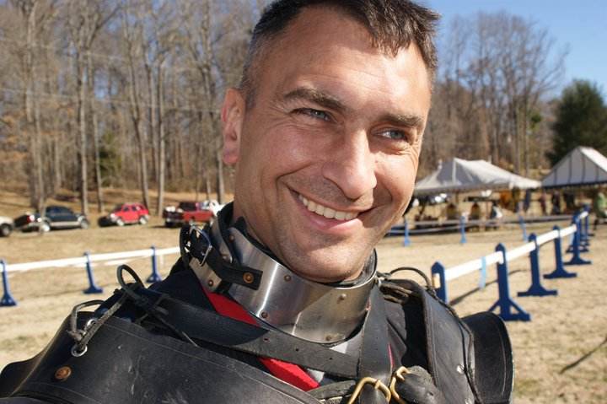

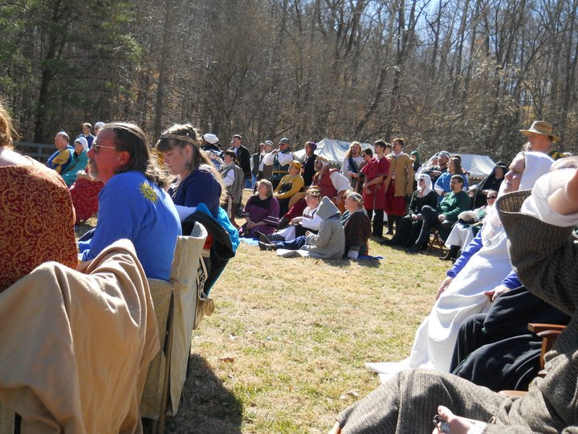
Raven’s Cove at Ymir.

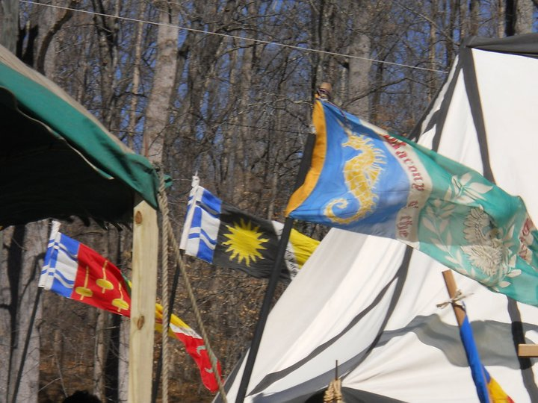
War pennants at Ymir.

